**The placement analysis of students in the college:**

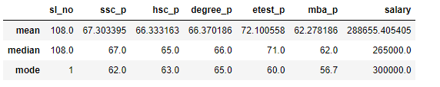

* Out of 214 students, the students get placed for an overall average salary of Rs.2,88,655, the most of the students placed for 3,00,000 salary and the median amount of salary they placed is 2,65,000.
* But those students scored average marks in SSC, HSC, Degree, Etest and MBA are 67.30, 66.33, 66.37, 72.10, and 62.27 respectively.
* The students scored median marks in SSC, HSC, Degree, Etest and MBA are 67, 65, 66, 71, and 62 respectively.
* The students scored the most repeated marks in SSC, HSC, Degree, Etest and MBA are 62, 63, 65, 60, and 56.7 respectively.
* Compared between mean, median, and mode of the SSC pass marks mean > median>mode so it is positively skewed distribution.
* In HSC pass marks mean > median > mode so it is positively skewed distribution.
* In Etest pass marks mean > median > mode so it is positively skewed distribution.
* In MBA pass marks mean > median > mode so it is positively skewed distribution.
* In salary mean > median > mode so it is positively skewed distribution.
* From this data we come to know that outliers are present in the positive side of the data.
* In a positive skew, the tail of a distribution curve is longer on the right side.
* This means the outliers of the distribution curve are further out towards the right and closer to the mean on the left.